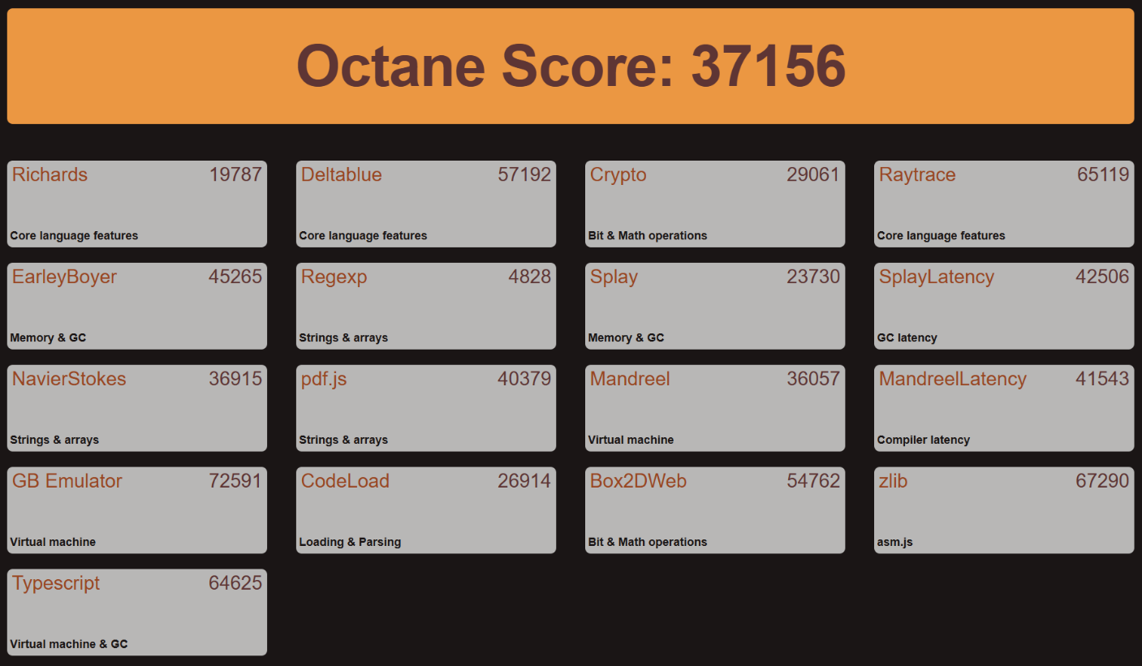**AMD Ryzen 5 3550H with Radeon Vega Mobile Gfx**

**苹果**

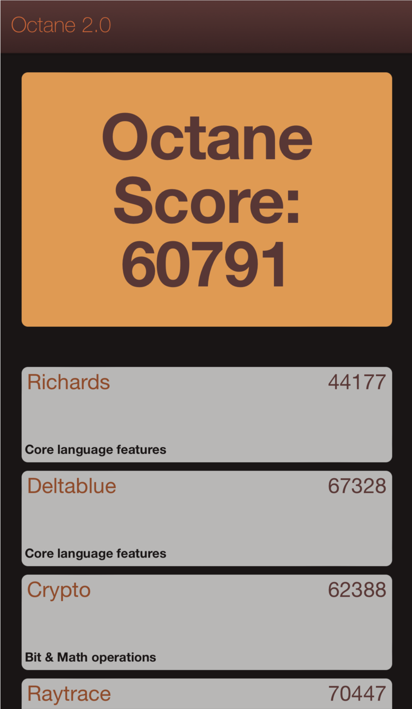

**华为 P40 pro+**

**38000**